**Initial Skypilot Selection Analyses**

Valerie Martin

9/20/2019

**Initial Skypilot Selection Analyse with 66% Pollination Percentage and 3.0 Seed Maturity**

**Loading data and creating subsets…**

**Supplementation Experiment**

Niki: “Can’t use cumberland pass (no supplmement seeds were successfully collected…triple checking that). Marginal interaction effect: total seeds per plant increased with supplementation of skunky, but not sweet, flowers. Sweet has this weird relationship where sup seedset goes up with flower size. Jake swears size differences shouldn’t have influenced the effectiveness of the treatment.”

**Sweet morph only**

Niki: “no effect of habitat => remove no treatment effect, but Candi saw this in some years - might it relate to weaking selection?” Val: “still figuring out how to get meaningful info with emmeans package instead of lsmeans”

**qqnorm**(fruit.sw.np**$**Total.SeedsPerPlant)  
**qqline**(fruit.sw.np**$**Total.SeedsPerPlant)

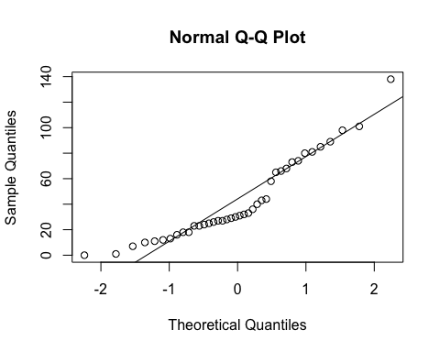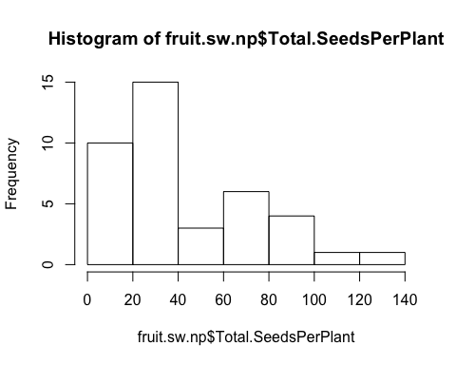

**hist**(fruit.sw.np**$**Total.SeedsPerPlant)

**qqnorm**(**sqrt**(fruit.sw.np**$**Total.SeedsPerPlant))  
**qqline**(**sqrt**(fruit.sw.np**$**Total.SeedsPerPlant))

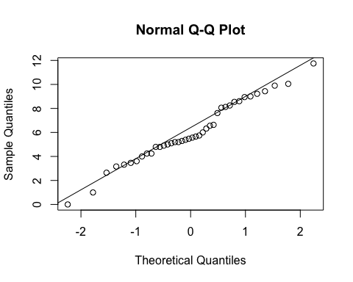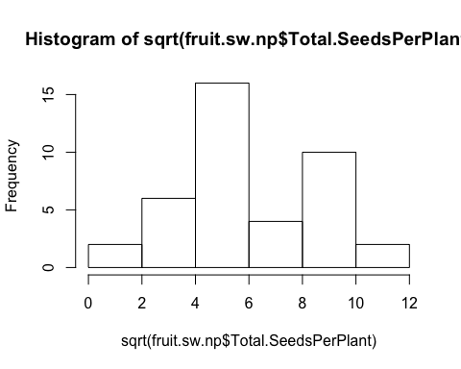

**hist**(**sqrt**(fruit.sw.np**$**Total.SeedsPerPlant))

basic.lm <- **lm**(**sqrt**(Total.SeedsPerPlant)**~**Treatment, data=fruit.sw.np)  
(prelim.plot <- **ggplot**(fruit.sw.np, **aes**(x=Treatment, y = Total.SeedsPerPlant))) **+**  
 **geom_point**()**+**  
 **geom_smooth**(method = "lm")

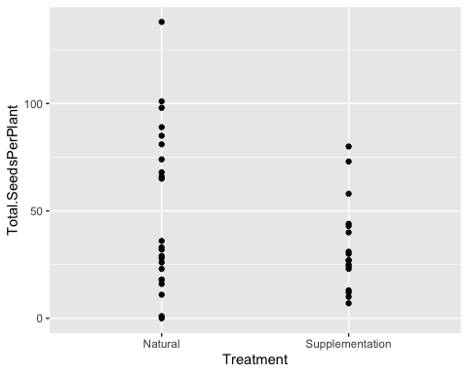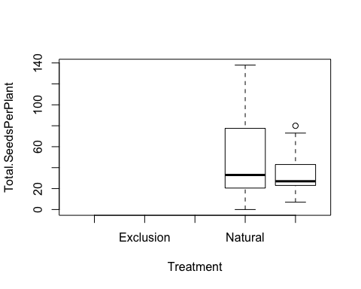

**boxplot**(Total.SeedsPerPlant **~** Treatment, data=fruit.sw.np)

**Selection - sweet flowers only**

*Would experience the strongest selection and sk flowers biased by habitat (almost exclusively in the krummholz).*

*Including Cumberland pass - replication is low but not biased.*

**Seeds per plant**

*Site*

**anova**(**lm**(**sqrt**(Total.SeedsPerPlant)**~**Site, data=fruit.sw.nat, na.action=na.omit))

## Analysis of Variance Table  
##   
## Response: sqrt(Total.SeedsPerPlant)  
##           Df  Sum Sq Mean Sq F value Pr(>F)    
## Site       2  83.923  41.962     5.2 0.0133 *  
## Residuals 24 193.668   8.069                   
## ---  
## Signif. codes:  0 '***' 0.001 '**' 0.01 '*' 0.05 '.' 0.1 ' ' 1

**TukeyHSD**(**aov**(**sqrt**(Total.SeedsPerPlant)**~**Site, data=fruit.sw.nat, na.action=na.omit))

##   Tukey multiple comparisons of means  
##     95% family-wise confidence level  
##   
## Fit: aov(formula = sqrt(Total.SeedsPerPlant) ~ Site, data = fruit.sw.nat, na.action = na.omit)  
##   
## $Site  
##                                   diff       lwr      upr     p adj  
## Niwot Ridge-Cumberland Pass   4.050889 -0.528269 8.630047 0.0899204  
## Penn Mountain-Cumberland Pass 5.090234  1.147964 9.032505 0.0097604  
## Penn Mountain-Niwot Ridge     1.039345 -2.329298 4.407989 0.7243314

**ggplot**(fruit.sw.nat, **aes**(x=Site,y=Total.SeedsPerPlant)) **+**  
 **geom_boxplot**() **+**   
 **scale_y_sqrt**()**+**  
 **theme_bw**() **+**  
 **theme**(panel.grid.major = **element_blank**(), panel.grid.minor = **element_blank**(), text =**element_text**(size=20))

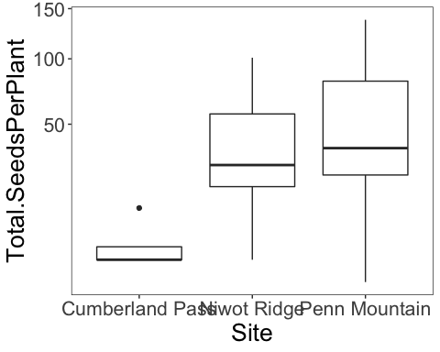

*Corolla Flare*

fit<-**lme**(**sqrt**(Total.SeedsPerPlant)**~**Avg.CorollaFlare, random=**~**1**|**Site, data=fruit.sw.nat, method="ML", na.action=na.omit)    
**anova.lme**(fit)

##                  numDF denDF  F-value p-value  
## (Intercept)          1    23 10.20778  0.0040  
## Avg.CorollaFlare     1    23  1.12512  0.2998

**ggplot**(fruit.sw.nat, **aes**(x=Avg.CorollaFlare,y=Total.SeedsPerPlant, color=Site)) **+**  
 **geom_point**(size=4) **+**   
 **scale_y_sqrt**()**+**  
 **ylab**("Seeds per plant") **+**  
 **xlab**("Corolla flare") **+**    
 **geom_hline**(yintercept=0) **+**  
 **theme_bw**() **+**  
 **theme**(panel.grid.major = **element_blank**(), panel.grid.minor = **element_blank**(), text =**element_text**(size=20), legend.position = "top")

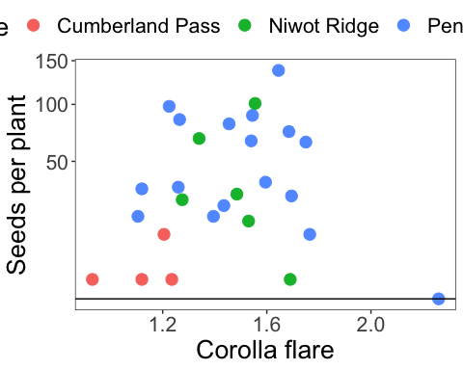

fit<-**lm**(**sqrt**(Total.SeedsPerPlant)**~**Avg.CorollaFlare**\***Site, data=fruit.sw.nat, na.action=na.omit)    
**Anova**(fit, type="III")

## Anova Table (Type III tests)  
##   
## Response: sqrt(Total.SeedsPerPlant)  
##                        Sum Sq Df F value Pr(>F)  
## (Intercept)             0.218  1  0.0268 0.8714  
## Avg.CorollaFlare        0.646  1  0.0796 0.7806  
## Site                   10.739  2  0.6615 0.5265  
## Avg.CorollaFlare:Site   5.716  2  0.3521 0.7073  
## Residuals             170.452 21

*Tube Length*

fit<-**lme**(**sqrt**(Total.SeedsPerPlant)**~**Avg.TubeL, random=**~**1**|**Site, data=fruit.sw.nat, method="ML", na.action=na.omit)    
**anova.lme**(fit)

##             numDF denDF   F-value p-value  
## (Intercept)     1    23 16.079840  0.0005  
## Avg.TubeL       1    23  0.098187  0.7568

**ggplot**(fruit.sw.nat, **aes**(x=Avg.TubeL,y=Total.SeedsPerPlant, color=Site)) **+**  
 **geom_point**(size=4) **+**   
 **scale_y_sqrt**()**+**  
 **ylab**("Seeds per plant") **+**  
 **xlab**("Tube length") **+**    
 **geom_hline**(yintercept=0) **+**  
 **theme_bw**() **+**  
 **theme**(panel.grid.major = **element_blank**(), panel.grid.minor = **element_blank**(), text =**element_text**(size=20), legend.position = "top")

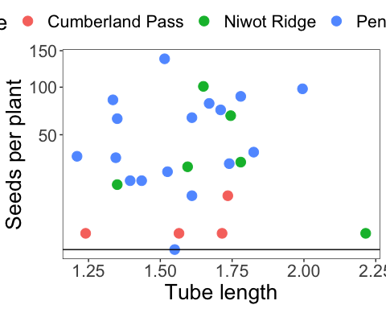

fit<-**lm**(**sqrt**(Total.SeedsPerPlant)**~**Avg.TubeL**\***Site, data=fruit.sw.nat, na.action=na.omit)    
**Anova**(fit, type="III")

## Anova Table (Type III tests)  
##   
## Response: sqrt(Total.SeedsPerPlant)  
##                 Sum Sq Df F value Pr(>F)  
## (Intercept)      0.356  1  0.0424 0.8389  
## Avg.TubeL        1.002  1  0.1195 0.7330  
## Site            16.729  2  0.9973 0.3857  
## Avg.TubeL:Site  16.967  2  1.0114 0.3807  
## Residuals      176.140 21

**Flower measurements combined via PCA**

**Flower measurements combined via PCA - Tube Length**

**cor**(fruit.sw.nat**$**Avg.CorollaFlare,fruit.sw.nat**$**Avg.TubeL)

## [1] 0.2598433

**cor.test**(fruit.sw.nat**$**Avg.CorollaFlare,fruit.sw.nat**$**Avg.TubeL)

##   
##  Pearson's product-moment correlation  
##   
## data:  fruit.sw.nat$Avg.CorollaFlare and fruit.sw.nat$Avg.TubeL  
## t = 1.3454, df = 25, p-value = 0.1906  
## alternative hypothesis: true correlation is not equal to 0  
## 95 percent confidence interval:  
##  -0.1333369  0.5823533  
## sample estimates:  
##       cor   
## 0.2598433

**plot**(fruit.sw.nat**$**Avg.CorollaFlare,fruit.sw.nat**$**Avg.TubeL)

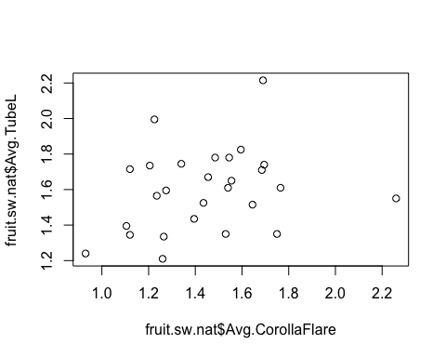

measures <- **c**("Avg.CorollaFlare", "Avg.TubeL")  
flwr.size<-**as.matrix**(**subset**(fruit.sw.nat, select=measures))  
pc<-**princomp**(flwr.size)  
pc<-**prcomp**(flwr.size,center=TRUE)  
**print**(pc)

## Standard deviations (1, .., p=2):  
## [1] 0.2916805 0.2103643  
##   
## Rotation (n x k) = (2 x 2):  
##                         PC1        PC2  
## Avg.CorollaFlare -0.8910616 -0.4538823  
## Avg.TubeL        -0.4538823  0.8910616

**plot**(pc, type="l")

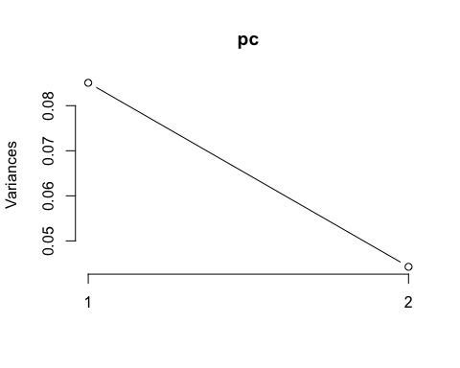

**summary**(pc)

## Importance of components:  
##                           PC1    PC2  
## Standard deviation     0.2917 0.2104  
## Proportion of Variance 0.6578 0.3422  
## Cumulative Proportion  0.6578 1.0000

pc.extracted <- **as.data.frame**(**predict**(pc, newdata=fruit.sw.nat))  
fruit.sw.nat**$**PC1 <- pc.extracted**$**PC1

**Flower measurement combined via PCA - Corolla Length**

fruit.sw.nat**$**CorollaL <- fruit.sw.nat**$**Avg.TubeL **+** fruit.sw.nat**$**Avg.LobeL  
**cor**(fruit.sw.nat**$**Avg.CorollaFlare,fruit.sw.nat**$**CorollaL)

## [1] 0.5499448

**cor.test**(fruit.sw.nat**$**Avg.CorollaFlare,fruit.sw.nat**$**CorollaL)

##   
##  Pearson's product-moment correlation  
##   
## data:  fruit.sw.nat$Avg.CorollaFlare and fruit.sw.nat$CorollaL  
## t = 3.2923, df = 25, p-value = 0.002961  
## alternative hypothesis: true correlation is not equal to 0  
## 95 percent confidence interval:  
##  0.2148267 0.7692051  
## sample estimates:  
##       cor   
## 0.5499448

**plot**(fruit.sw.nat**$**Avg.CorollaFlare,fruit.sw.nat**$**CorollaL)

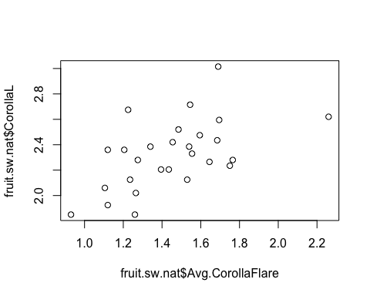

measures <- **c**("CorollaL", "Avg.CorollaFlare")  
flwr.size<-**as.matrix**(**subset**(fruit.sw.nat, select=measures))  
pc<-**prcomp**(flwr.size,center=TRUE)  
**print**(pc)

## Standard deviations (1, .., p=2):  
## [1] 0.3407349 0.1835138  
##   
## Rotation (n x k) = (2 x 2):  
##                         PC1        PC2  
## CorollaL         -0.6916805 -0.7222036  
## Avg.CorollaFlare -0.7222036  0.6916805

**plot**(pc, type="l")

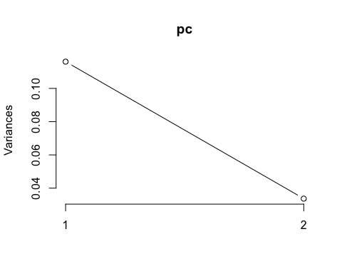

**summary**(pc)

## Importance of components:  
##                           PC1    PC2  
## Standard deviation     0.3407 0.1835  
## Proportion of Variance 0.7752 0.2248  
## Cumulative Proportion  0.7752 1.0000

pc.extracted <- **as.data.frame**(**predict**(pc, newdata=fruit.sw.nat))  
fruit.sw.nat**$**PC1.cl <- pc.extracted**$**PC1

**Flower measurements combined via pca (all 4 traits - same as pressed)**

measures <- **c**("Avg.CorollaFlare", "Avg.TubeL", "Avg.LobeL", "Avg.LobW")  
flwr.size<-**as.matrix**(**subset**(fruit.sw.nat, select=measures))  
pc<-**prcomp**(flwr.size,center=TRUE)  
**print**(pc)

## Standard deviations (1, .., p=4):  
## [1] 0.31544679 0.21652186 0.06689248 0.05384536  
##   
## Rotation (n x k) = (4 x 4):  
##                         PC1        PC2         PC3         PC4  
## Avg.CorollaFlare -0.8525504  0.2736270 -0.40363489  0.18805578  
## Avg.TubeL        -0.3380001 -0.9382985  0.05579185 -0.04731994  
## Avg.LobeL        -0.2862811  0.1360535  0.87137909  0.37447442  
## Avg.LobW         -0.2774111  0.1619064  0.27324828 -0.90673301

**plot**(pc, type="l")

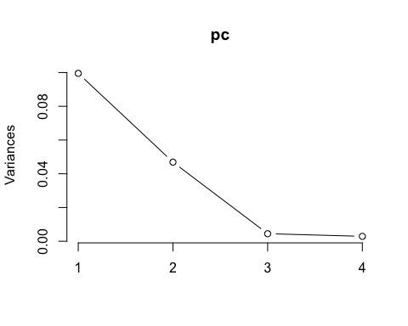

**summary**(pc)

## Importance of components:  
##                           PC1    PC2     PC3     PC4  
## Standard deviation     0.3154 0.2165 0.06689 0.05385  
## Proportion of Variance 0.6472 0.3049 0.02910 0.01886  
## Cumulative Proportion  0.6472 0.9520 0.98114 1.00000

pc.extracted <- **as.data.frame**(**predict**(pc, newdata=fruit.sw.nat))  
*##### Inverted PC1 when added to the df, because all loadings were negative.  This way, larger PC denotes a larger flower.*  
fruit.sw.nat**$**PC1.all <- **-**pc.extracted**$**PC1

**Total seedset per plant (annual fecundity)**

fit<-**lme**(**sqrt**(Total.SeedsPerPlant)**~**PC1.all, random=**~**1**|**Site, data=fruit.sw.nat, method="ML", na.action=na.omit)    
**anova.lme**(fit)

##             numDF denDF   F-value p-value  
## (Intercept)     1    23 11.827524  0.0022  
## PC1.all         1    23  0.533522  0.4725

**ggplot**(fruit.sw.nat, **aes**(x=PC1,y=Total.SeedsPerPlant, color=Site)) **+**  
 **geom_point**(size=4) **+**   
 **scale_y_sqrt**()**+**  
 **ylab**("Seeds per plant") **+**  
 **xlab**("PC1") **+**    
 **geom_hline**(yintercept=0) **+**  
 **theme_bw**() **+**  
 **theme**(panel.grid.major = **element_blank**(), panel.grid.minor = **element_blank**(), text =**element_text**(size=20), legend.position = "top")

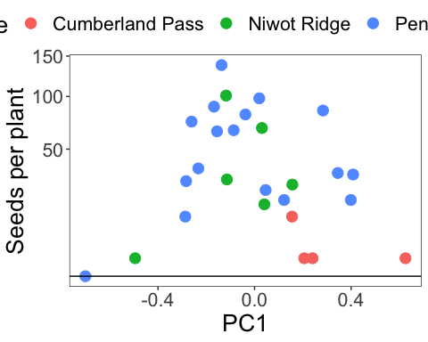

fit<-**lme**(**sqrt**(Total.SeedsPerPlant)**~**PC1.cl, random=**~**1**|**Site, data=fruit.sw.nat, method="ML", na.action=na.omit)    
**anova.lme**(fit)

##             numDF denDF   F-value p-value  
## (Intercept)     1    23 12.937900  0.0015  
## PC1.cl          1    23  0.318541  0.5779

**Relative fecundity (standardized by max annual fecundity)**

**max**(fruit.sw.nat**$**Total.SeedsPerPlant)

## [1] 138

fruit.sw.nat**$**RelativeFitness <- fruit.sw.nat**$**Total.SeedsPerPlant**/**138  
  
**qqnorm**(fruit.sw.nat**$**RelativeFitness)  
**qqline**(fruit.sw.nat**$**RelativeFitness)

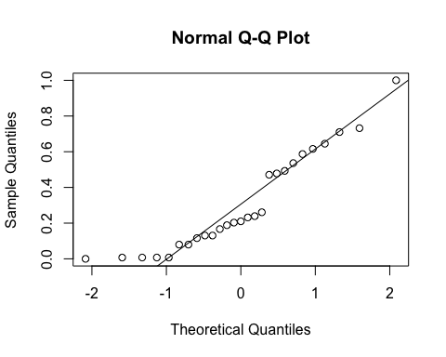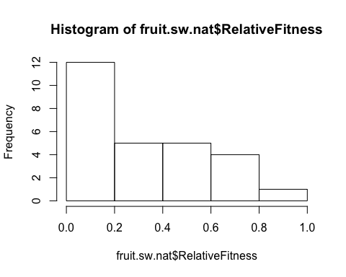

**hist**(fruit.sw.nat**$**RelativeFitness)

**qqnorm**(**sqrt**(fruit.sw.nat**$**RelativeFitness))  
**qqline**(**sqrt**(fruit.sw.nat**$**RelativeFitness))

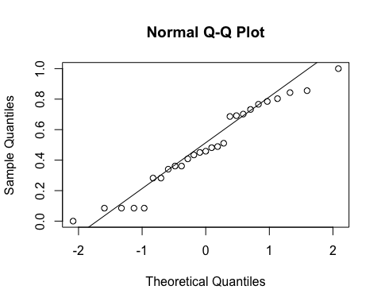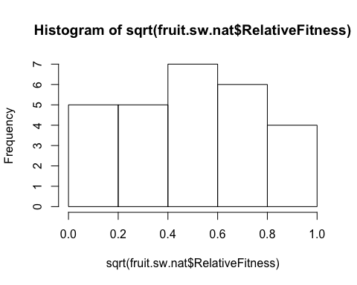

**hist**(**sqrt**(fruit.sw.nat**$**RelativeFitness))

fit<-**lme**(**sqrt**(RelativeFitness)**~**PC1, random=**~**1**|**Site, data=fruit.sw.nat, method="ML", na.action=na.omit)    
**anova.lme**(fit)

##             numDF denDF   F-value p-value  
## (Intercept)     1    23 12.281455  0.0019  
## PC1             1    23  0.449147  0.5094

**ggplot**(fruit.sw.nat, **aes**(x=PC1,y=RelativeFitness)) **+**  
 **geom_point**(size=2) **+**   
 **scale_y_sqrt**()**+**  
 **scale_colour_manual**(values=**c**("black")) **+**  
 **ylab**("Relative fitness") **+**  
 **xlab**("PC1") **+**    
 **geom_hline**(yintercept=0) **+**  
 **theme_bw**() **+**  
 **theme**(panel.grid.major = **element_blank**(), panel.grid.minor = **element_blank**(), text =**element_text**(size=20))

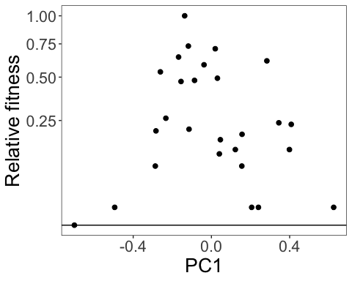

fit<-**lme**(**sqrt**(RelativeFitness)**~**PC1.cl, random=**~**1**|**Site, data=fruit.sw.nat, method="ML", na.action=na.omit)    
**anova.lme**(fit)

##             numDF denDF   F-value p-value  
## (Intercept)     1    23 12.937900  0.0015  
## PC1.cl          1    23  0.318541  0.5779

**ggplot**(fruit.sw.nat, **aes**(x=PC1.cl,y=RelativeFitness)) **+**  
 **geom_point**(size=2) **+**   
 **scale_y_sqrt**()**+**  
 **scale_colour_manual**(values=**c**("black")) **+**  
 **xlim**(**-**1,1) **+**  
 **ylab**("Relative fitness") **+**  
 **xlab**("PC1") **+**    
 **geom_hline**(yintercept=0) **+**  
 **theme_bw**() **+**  
 **theme**(panel.grid.major = **element_blank**(), panel.grid.minor = **element_blank**(), text =**element_text**(size=20))

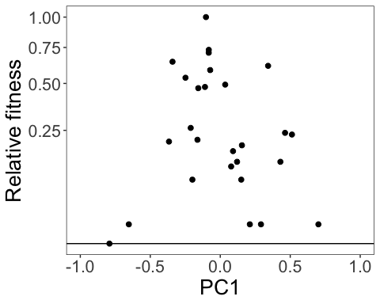

fit<-**lme**(**sqrt**(RelativeFitness)**~**Avg.CorollaFlare, random=**~**1**|**Site, data=fruit.sw.nat, method="ML", na.action=na.omit)    
**anova.lme**(fit)

##                  numDF denDF  F-value p-value  
## (Intercept)          1    23 10.20778  0.0040  
## Avg.CorollaFlare     1    23  1.12512  0.2998

**ggplot**(fruit.sw.nat, **aes**(x=CorollaL,y=RelativeFitness)) **+**  
 **geom_point**(size=2) **+**   
 **scale_y_sqrt**()**+**  
 **ylab**("Relative fitness") **+**  
 **xlab**("Corolla flare (cm)") **+**    
 **geom_hline**(yintercept=0) **+**  
 **theme_bw**() **+**  
 **theme**(panel.grid.major = **element_blank**(), panel.grid.minor = **element_blank**(), text =**element_text**(size=20))

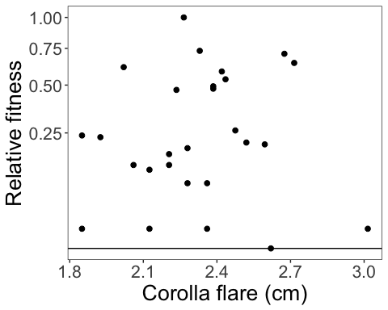

fit<-**lme**(**sqrt**(RelativeFitness)**~**CorollaL, random=**~**1**|**Site, data=fruit.sw.nat, method="ML", na.action=na.omit)    
**anova.lme**(fit)

##             numDF denDF   F-value p-value  
## (Intercept)     1    23 15.851774  0.0006  
## CorollaL        1    23  0.000933  0.9759

**ggplot**(fruit.sw.nat, **aes**(x=CorollaL,y=RelativeFitness)) **+**  
 **geom_point**(size=2) **+**   
 **scale_y_sqrt**()**+**  
 **ylab**("Relative fitness") **+**  
 **xlab**("Corolla length (cm)") **+**    
 **geom_hline**(yintercept=0) **+**  
 **theme_bw**() **+**  
 **theme**(panel.grid.major = **element_blank**(), panel.grid.minor = **element_blank**(), text =**element_text**(size=20))

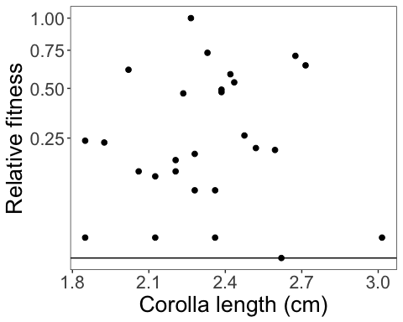

fit<-**lme**(**sqrt**(RelativeFitness)**~**Avg.TubeL, random=**~**1**|**Site, data=fruit.sw.nat, method="ML", na.action=na.omit)    
**anova.lme**(fit)

##             numDF denDF   F-value p-value  
## (Intercept)     1    23 16.079840  0.0005  
## Avg.TubeL       1    23  0.098187  0.7568

**ggplot**(fruit.sw.nat, **aes**(x=Avg.TubeL,y=RelativeFitness)) **+**  
 **geom_point**(size=2) **+**   
 **scale_y_sqrt**()**+**  
 **ylab**("Relative fitness") **+**  
 **xlab**("Flower tube length (cm)") **+**    
 **geom_hline**(yintercept=0) **+**  
 **theme_bw**() **+**  
 **theme**(panel.grid.major = **element_blank**(), panel.grid.minor = **element_blank**(), text =**element_text**(size=20))

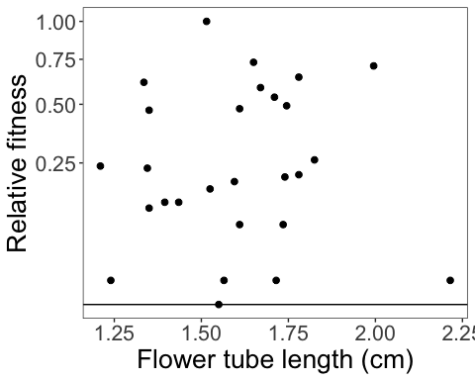

**With supplementation treatment**

*(treatment was more effective for larger flowers…Jake swears flwr size didn’t affect the trmt)*

**Total seedset per plant**

**qqnorm**(fruit.sw**$**Total.SeedsPerPlant)  
**qqline**(fruit.sw**$**Total.SeedsPerPlant)

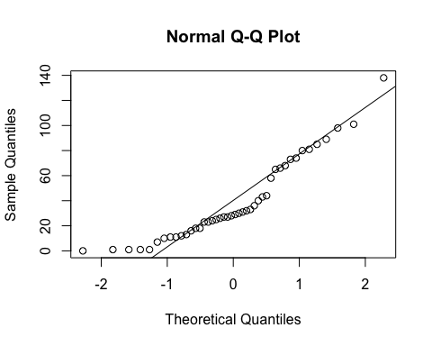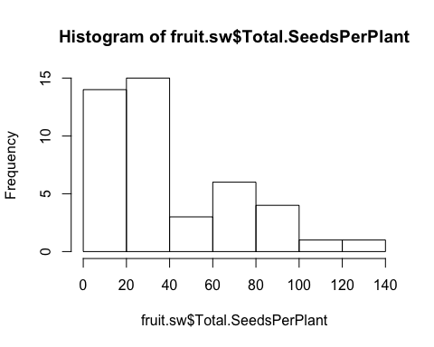

**hist**(fruit.sw**$**Total.SeedsPerPlant)

**qqnorm**(**sqrt**(fruit.sw**$**Total.SeedsPerPlant))  
**qqline**(**sqrt**(fruit.sw**$**Total.SeedsPerPlant))

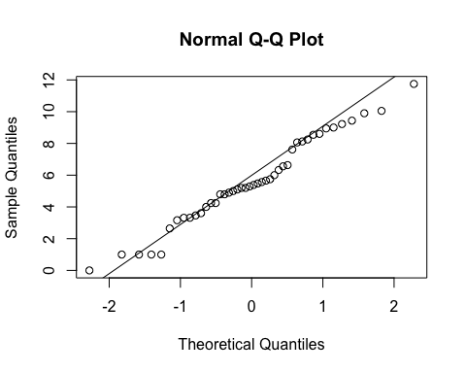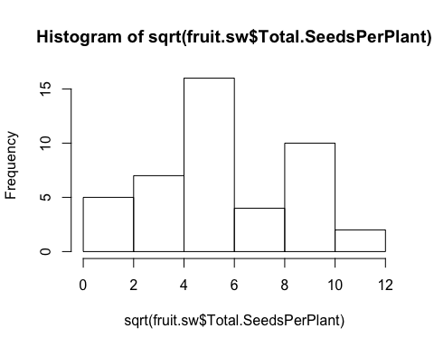

**hist**(**sqrt**(fruit.sw**$**Total.SeedsPerPlant))

fit<-**lme**(**sqrt**(Total.SeedsPerPlant)**~**Treatment**\***Avg.CorollaFlare, random=**~**1**|**Site**/**Habitat, data=fruit.sw, method="ML", na.action=na.omit)    
**anova.lme**(fit)

##                            numDF denDF  F-value p-value  
## (Intercept)                    1    35 8.341173  0.0066  
## Treatment                      1    35 1.184560  0.2839  
## Avg.CorollaFlare               1    35 0.155066  0.6961  
## Treatment:Avg.CorollaFlare     1    35 3.888334  0.0566

**summary**(fit)

## Linear mixed-effects model fit by maximum likelihood  
##  Data: fruit.sw   
##        AIC     BIC    logLik  
##   219.9247 232.414 -102.9623  
##   
## Random effects:  
##  Formula: ~1 | Site  
##         (Intercept)  
## StdDev:     2.39707  
##   
##  Formula: ~1 | Habitat %in% Site  
##         (Intercept) Residual  
## StdDev:   0.7582496 2.252069  
##   
## Fixed effects: sqrt(Total.SeedsPerPlant) ~ Treatment * Avg.CorollaFlare   
##                                               Value Std.Error DF   t-value  
## (Intercept)                                8.914225  3.071207 35  2.902515  
## TreatmentSupplementation                  -9.773810  4.609832 35 -2.120210  
## Avg.CorollaFlare                          -3.039675  1.904362 35 -1.596165  
## TreatmentSupplementation:Avg.CorollaFlare  5.897807  2.990948 35  1.971886  
##                                           p-value  
## (Intercept)                                0.0064  
## TreatmentSupplementation                   0.0412  
## Avg.CorollaFlare                           0.1194  
## TreatmentSupplementation:Avg.CorollaFlare  0.0566  
##  Correlation:   
##                                           (Intr) TrtmnS Avg.CF  
## TreatmentSupplementation                  -0.553                
## Avg.CorollaFlare                          -0.858  0.642         
## TreatmentSupplementation:Avg.CorollaFlare  0.556 -0.986 -0.659  
##   
## Standardized Within-Group Residuals:  
##        Min         Q1        Med         Q3        Max   
## -1.6535001 -0.6554719 -0.1599848  0.7706235  2.2606567   
##   
## Number of Observations: 44  
## Number of Groups:   
##              Site Habitat %in% Site   
##                 3                 6

**ggplot**(fruit.sw, **aes**(x=Avg.CorollaFlare,y=Total.SeedsPerPlant, color=Treatment, shape=Treatment)) **+**  
 **scale_shape_manual**(values=**c**(16,17)) **+**  
 **geom_point**(size=4) **+**   
 **scale_y_sqrt**()**+**  
 **scale_colour_manual**(values=**c**("blue", "red")) **+**  
 **geom_smooth**(method='lm', fill=NA) **+**  
 **theme_bw**() **+**  
 **theme**(panel.grid.major = **element_blank**(), panel.grid.minor = **element_blank**(), text =**element_text**(size=20))

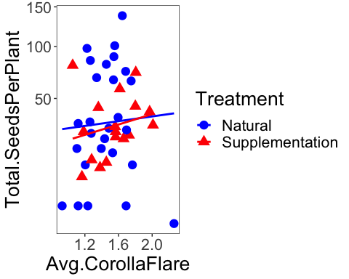

fit<-**lme**(**sqrt**(Total.SeedsPerPlant)**~**Avg.CorollaFlare, random=**~**1**|**Site**/**Habitat, data=fruit.sw.nat, method="ML", na.action=na.omit)    
**anova.lme**(fit)

##                  numDF denDF  F-value p-value  
## (Intercept)          1    20 9.498676  0.0059  
## Avg.CorollaFlare     1    20 1.589829  0.2219

fit<-**lme**(**sqrt**(Total.SeedsPerPlant)**~**Avg.CorollaFlare, random=**~**1**|**Site**/**Habitat, data=fruit.sw.sup, method="ML", na.action=na.omit)    
**anova.lme**(fit)

##                  numDF denDF   F-value p-value  
## (Intercept)          1    12 158.85185  <.0001  
## Avg.CorollaFlare     1    12   0.81189  0.3853

fit<-**lme**(**sqrt**(Total.SeedsPerPlant)**~**Treatment**\***Avg.TubeL, random=**~**1**|**Site**/**Habitat, data=fruit.sw, method="ML", na.action=na.omit)    
**anova.lme**(fit)

##                     numDF denDF   F-value p-value  
## (Intercept)             1    35 15.415658  0.0004  
## Treatment               1    35  0.663019  0.4210  
## Avg.TubeL               1    35  0.036253  0.8501  
## Treatment:Avg.TubeL     1    35  0.504436  0.4823

fit<-**lme**(**sqrt**(Total.SeedsPerPlant)**~**Treatment**\***CorollaL, random=**~**1**|**Site**/**Habitat, data=fruit.sw, method="ML", na.action=na.omit)    
**anova.lme**(fit)

##                    numDF denDF   F-value p-value  
## (Intercept)            1    35 14.600667  0.0005  
## Treatment              1    35  0.694356  0.4103  
## CorollaL               1    35  0.268911  0.6073  
## Treatment:CorollaL     1    35  0.159314  0.6922

**Seeds per fruit**

**qqnorm**(fruit.sw**$**No.SeedsPerFruit)  
**qqline**(fruit.sw**$**No.SeedsPerFruit)

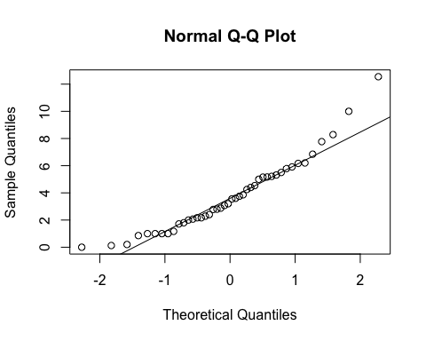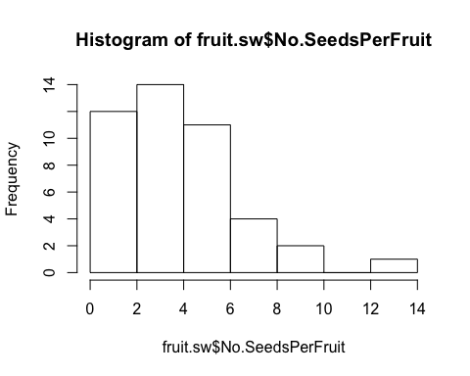

**hist**(fruit.sw**$**No.SeedsPerFruit)

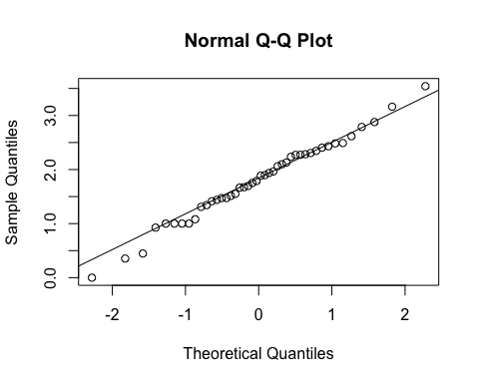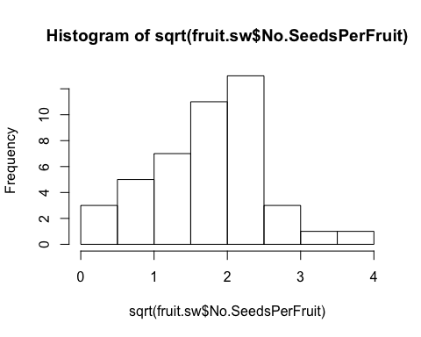

**qqnorm**(**sqrt**(fruit.sw**$**No.SeedsPerFruit))  
**qqline**(**sqrt**(fruit.sw**$**No.SeedsPerFruit))

**hist**(**sqrt**(fruit.sw**$**No.SeedsPerFruit))

fit<-**lme**(**sqrt**(No.SeedsPerFruit)**~**Treatment**\***Avg.CorollaFlare, random=**~**1**|**Site**/**Habitat, data=fruit.sw, method="ML", na.action=na.omit)    
**anova.lme**(fit)

##                            numDF denDF   F-value p-value  
## (Intercept)                    1    35 18.592114  0.0001  
## Treatment                      1    35  0.196553  0.6602  
## Avg.CorollaFlare               1    35  0.075991  0.7844  
## Treatment:Avg.CorollaFlare     1    35  5.591868  0.0237

**summary**(fit)

## Linear mixed-effects model fit by maximum likelihood  
##  Data: fruit.sw   
##        AIC      BIC    logLik  
##   103.1445 115.6338 -44.57225  
##   
## Random effects:  
##  Formula: ~1 | Site  
##         (Intercept)  
## StdDev:   0.5401024  
##   
##  Formula: ~1 | Habitat %in% Site  
##         (Intercept)  Residual  
## StdDev:   0.1605937 0.6074675  
##   
## Fixed effects: sqrt(No.SeedsPerFruit) ~ Treatment * Avg.CorollaFlare   
##                                                Value Std.Error DF  
## (Intercept)                                2.7344212 0.7933423 35  
## TreatmentSupplementation                  -2.7821004 1.2337711 35  
## Avg.CorollaFlare                          -0.8951161 0.5087602 35  
## TreatmentSupplementation:Avg.CorollaFlare  1.8951117 0.8014130 35  
##                                             t-value p-value  
## (Intercept)                                3.446710  0.0015  
## TreatmentSupplementation                  -2.254957  0.0305  
## Avg.CorollaFlare                          -1.759407  0.0872  
## TreatmentSupplementation:Avg.CorollaFlare  2.364713  0.0237  
##  Correlation:   
##                                           (Intr) TrtmnS Avg.CF  
## TreatmentSupplementation                  -0.570                
## Avg.CorollaFlare                          -0.889  0.638         
## TreatmentSupplementation:Avg.CorollaFlare  0.573 -0.986 -0.656  
##   
## Standardized Within-Group Residuals:  
##        Min         Q1        Med         Q3        Max   
## -1.9284270 -0.5193045 -0.1462434  0.5170519  2.6505958   
##   
## Number of Observations: 44  
## Number of Groups:   
##              Site Habitat %in% Site   
##                 3                 6

**ggplot**(fruit.sw, **aes**(x=Avg.CorollaFlare,y=No.SeedsPerFruit, color=Treatment, shape=Treatment)) **+**  
 **scale_shape_manual**(values=**c**(16,17)) **+**  
 **geom_point**(size=4) **+**   
 **scale_y_sqrt**()**+**  
 **scale_colour_manual**(values=**c**("blue", "red")) **+**  
 **geom_smooth**(method='lm', fill=NA) **+**  
 **theme_bw**() **+**  
 **theme**(panel.grid.major = **element_blank**(), panel.grid.minor = **element_blank**(), text =**element_text**(size=20))

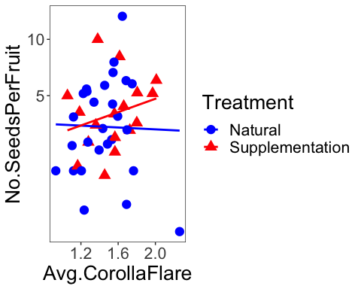

fit<-**lme**(**sqrt**(No.SeedsPerFruit)**~**Treatment**\***Avg.TubeL, random=**~**1**|**Site**/**Habitat, data=fruit.sw, method="ML", na.action=na.omit)    
**anova.lme**(fit)

##                     numDF denDF  F-value p-value  
## (Intercept)             1    35 43.02576  <.0001  
## Treatment               1    35  0.41510  0.5236  
## Avg.TubeL               1    35  0.23212  0.6330  
## Treatment:Avg.TubeL     1    35  0.06873  0.7947

**summary**(fit)

## Linear mixed-effects model fit by maximum likelihood  
##  Data: fruit.sw   
##        AIC      BIC    logLik  
##   107.5553 120.0447 -46.77767  
##   
## Random effects:  
##  Formula: ~1 | Site  
##         (Intercept)  
## StdDev:   0.3426639  
##   
##  Formula: ~1 | Habitat %in% Site  
##          (Intercept) Residual  
## StdDev: 0.0001788278 0.667405  
##   
## Fixed effects: sqrt(No.SeedsPerFruit) ~ Treatment * Avg.TubeL   
##                                         Value Std.Error DF    t-value  
## (Intercept)                         2.0939179 1.0149215 35  2.0631328  
## TreatmentSupplementation           -0.2557142 1.6341609 35 -0.1564805  
## Avg.TubeL                          -0.3324871 0.6105167 35 -0.5445995  
## TreatmentSupplementation:Avg.TubeL  0.2530435 0.9651786 35  0.2621728  
##                                    p-value  
## (Intercept)                         0.0466  
## TreatmentSupplementation            0.8766  
## Avg.TubeL                           0.5895  
## TreatmentSupplementation:Avg.TubeL  0.7947  
##  Correlation:   
##                                    (Intr) TrtmnS Avg.TL  
## TreatmentSupplementation           -0.528                
## Avg.TubeL                          -0.968  0.547         
## TreatmentSupplementation:Avg.TubeL  0.549 -0.990 -0.579  
##   
## Standardized Within-Group Residuals:  
##        Min         Q1        Med         Q3        Max   
## -2.8575092 -0.5086414 -0.1223830  0.5694207  2.4321108   
##   
## Number of Observations: 44  
## Number of Groups:   
##              Site Habitat %in% Site   
##                 3                 6

fit<-**lme**(**sqrt**(No.SeedsPerFruit)**~**Treatment**\***Avg.LobW, random=**~**1**|**Site**/**Habitat, data=fruit.sw, method="ML")    
**anova.lme**(fit)

##                    numDF denDF  F-value p-value  
## (Intercept)            1    35 34.20557  <.0001  
## Treatment              1    35  0.35240  0.5566  
## Avg.LobW               1    35  0.25267  0.6184  
## Treatment:Avg.LobW     1    35  1.48388  0.2313

**summary**(fit)

## Linear mixed-effects model fit by maximum likelihood  
##  Data: fruit.sw   
##        AIC      BIC    logLik  
##   106.0891 118.5784 -46.04454  
##   
## Random effects:  
##  Formula: ~1 | Site  
##         (Intercept)  
## StdDev:   0.3913761  
##   
##  Formula: ~1 | Habitat %in% Site  
##         (Intercept)  Residual  
## StdDev:  0.05625338 0.6497809  
##   
## Fixed effects: sqrt(No.SeedsPerFruit) ~ Treatment * Avg.LobW   
##                                       Value Std.Error DF    t-value  
## (Intercept)                        1.910206 0.9833162 35  1.9426164  
## TreatmentSupplementation          -1.882322 1.6494228 35 -1.1412004  
## Avg.LobW                          -0.529024 1.3272415 35 -0.3985891  
## TreatmentSupplementation:Avg.LobW  2.618460 2.1495440 35  1.2181466  
##                                   p-value  
## (Intercept)                        0.0601  
## TreatmentSupplementation           0.2615  
## Avg.LobW                           0.6926  
## TreatmentSupplementation:Avg.LobW  0.2313  
##  Correlation:   
##                                   (Intr) TrtmnS Avg.LW  
## TreatmentSupplementation          -0.598                
## Avg.LobW                          -0.959  0.619         
## TreatmentSupplementation:Avg.LobW  0.612 -0.991 -0.643  
##   
## Standardized Within-Group Residuals:  
##         Min          Q1         Med          Q3         Max   
## -2.70730948 -0.53823864 -0.07906756  0.68943868  2.51051963   
##   
## Number of Observations: 44  
## Number of Groups:   
##              Site Habitat %in% Site   
##                 3                 6

fit<-**lme**(**sqrt**(No.SeedsPerFruit)**~**Treatment**\***Avg.LobeL, random=**~**1**|**Site**/**Habitat, data=fruit.sw, method="ML")    
**anova.lme**(fit)

##                     numDF denDF   F-value p-value  
## (Intercept)             1    35 22.843511  <.0001  
## Treatment               1    35  0.230086  0.6344  
## Avg.LobeL               1    35  0.492596  0.4874  
## Treatment:Avg.LobeL     1    35  3.075632  0.0882

**summary**(fit)

## Linear mixed-effects model fit by maximum likelihood  
##  Data: fruit.sw   
##        AIC      BIC    logLik  
##   104.7572 117.2465 -45.37858  
##   
## Random effects:  
##  Formula: ~1 | Site  
##         (Intercept)  
## StdDev:   0.4830953  
##   
##  Formula: ~1 | Habitat %in% Site  
##         (Intercept) Residual  
## StdDev:   0.1395662 0.625809  
##   
## Fixed effects: sqrt(No.SeedsPerFruit) ~ Treatment * Avg.LobeL   
##                                        Value Std.Error DF   t-value  
## (Intercept)                         2.766655 0.9274535 35  2.983066  
## TreatmentSupplementation           -3.462356 2.0436582 35 -1.694195  
## Avg.LobeL                          -1.793081 1.2352109 35 -1.451639  
## TreatmentSupplementation:Avg.LobeL  4.817211 2.7468090 35  1.753748  
##                                    p-value  
## (Intercept)                         0.0052  
## TreatmentSupplementation            0.0991  
## Avg.LobeL                           0.1555  
## TreatmentSupplementation:Avg.LobeL  0.0882  
##  Correlation:   
##                                    (Intr) TrtmnS Avg.LL  
## TreatmentSupplementation           -0.440                
## Avg.LobeL                          -0.934  0.472         
## TreatmentSupplementation:Avg.LobeL  0.436 -0.995 -0.476  
##   
## Standardized Within-Group Residuals:  
##           Min            Q1           Med            Q3           Max   
## -2.0355072293 -0.4920996099  0.0008730626  0.5681836783  2.4556515578   
##   
## Number of Observations: 44  
## Number of Groups:   
##              Site Habitat %in% Site   
##                 3                 6

**Both morphs: natural treatment only**

**Seeds per plant**

*Without supplementation treatment*

**qqnorm**(fruit.nat**$**Total.SeedsPerPlant)  
**qqline**(fruit.nat**$**Total.SeedsPerPlant)

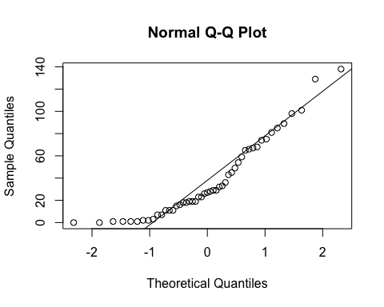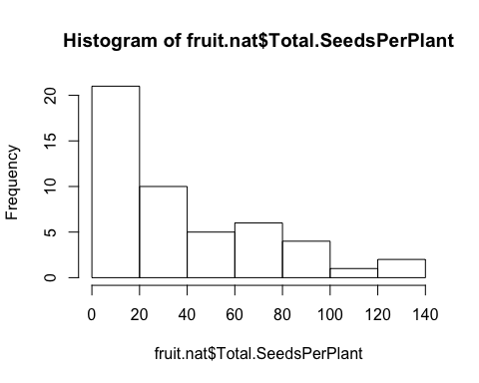

**hist**(fruit.nat**$**Total.SeedsPerPlant)

**qqnorm**(**sqrt**(fruit.nat**$**Total.SeedsPerPlant))  
**qqline**(**sqrt**(fruit.nat**$**Total.SeedsPerPlant))

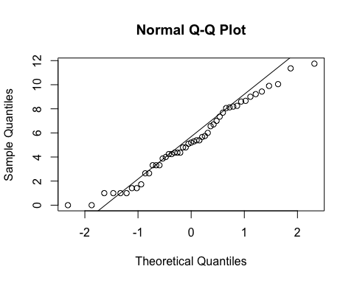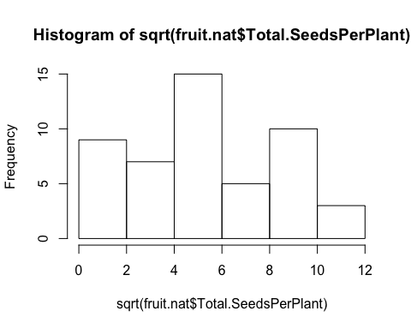

**hist**(**sqrt**(fruit.nat**$**Total.SeedsPerPlant))

*####Site*  
**anova**(**lm**(**sqrt**(Total.SeedsPerPlant)**~**Morph, data=fruit.nat, na.action=na.omit))

## Analysis of Variance Table  
##   
## Response: sqrt(Total.SeedsPerPlant)  
##           Df Sum Sq Mean Sq F value Pr(>F)  
## Morph      1   6.46  6.4607  0.6876 0.4112  
## Residuals 47 441.60  9.3958

**anova**(**lm**(**sqrt**(Total.SeedsPerPlant)**~**Site, data=fruit.nat, na.action=na.omit))

## Analysis of Variance Table  
##   
## Response: sqrt(Total.SeedsPerPlant)  
##           Df Sum Sq Mean Sq F value   Pr(>F)     
## Site       2 113.81  56.903  7.8309 0.001183 **  
## Residuals 46 334.26   7.266                      
## ---  
## Signif. codes:  0 '***' 0.001 '**' 0.01 '*' 0.05 '.' 0.1 ' ' 1

**TukeyHSD**(**aov**(**sqrt**(Total.SeedsPerPlant)**~**Site, data=fruit.nat, na.action=na.omit))

##   Tukey multiple comparisons of means  
##     95% family-wise confidence level  
##   
## Fit: aov(formula = sqrt(Total.SeedsPerPlant) ~ Site, data = fruit.nat, na.action = na.omit)  
##   
## $Site  
##                                   diff         lwr      upr     p adj  
## Niwot Ridge-Cumberland Pass   2.596036 -0.07846659 5.270538 0.0587711  
## Penn Mountain-Cumberland Pass 3.858700  1.49664373 6.220756 0.0007510  
## Penn Mountain-Niwot Ridge     1.262665 -0.96965041 3.494979 0.3648907

**ggplot**(fruit.nat, **aes**(x=Site,y=No.SeedsPerFruit)) **+**  
 **geom_boxplot**() **+**   
 **scale_y_sqrt**()**+**  
 **theme_bw**() **+**  
 **theme**(panel.grid.major = **element_blank**(), panel.grid.minor = **element_blank**(), text =**element_text**(size=20))

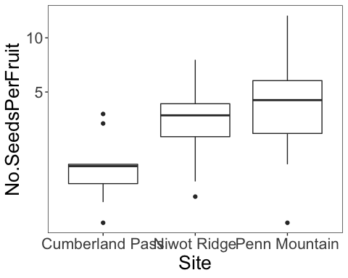

*#corolla flare*  
fit<-**lme**(**sqrt**(Total.SeedsPerPlant)**~**Avg.CorollaFlare**\***Morph, random=**~**1**|**Site, data=fruit.nat, method="ML", na.action=na.omit)    
**anova.lme**(fit)

##                        numDF denDF   F-value p-value  
## (Intercept)                1    43 19.787241  0.0001  
## Avg.CorollaFlare           1    43  0.885149  0.3521  
## Morph                      1    43  0.001512  0.9692  
## Avg.CorollaFlare:Morph     1    43  0.006434  0.9364

*#tube length*  
fit<-**lme**(**sqrt**(Total.SeedsPerPlant)**~**Avg.TubeL**\***Morph, random=**~**1**|**Site, data=fruit.nat, method="ML", na.action=na.omit)    
**anova.lme**(fit)

##                 numDF denDF   F-value p-value  
## (Intercept)         1    43 26.797138  <.0001  
## Avg.TubeL           1    43  0.052773  0.8194  
## Morph               1    43  0.034111  0.8543  
## Avg.TubeL:Morph     1    43  0.062695  0.8035

**Flower measurements combined via pca (all 4 traits - same as pressed)**

measures <- **c**("Avg.CorollaFlare", "Avg.TubeL", "Avg.LobeL", "Avg.LobW")  
flwr.size<-**as.matrix**(**subset**(fruit.nat, select=measures))  
pc<-**prcomp**(flwr.size,center=TRUE)  
**print**(pc)

## Standard deviations (1, .., p=4):  
## [1] 0.27540663 0.21615741 0.08791553 0.06686588  
##   
## Rotation (n x k) = (4 x 4):  
##                        PC1         PC2         PC3         PC4  
## Avg.CorollaFlare 0.8189029  0.37412192  0.41576823 -0.12871530  
## Avg.TubeL        0.4251882 -0.90236669 -0.00372828  0.07025269  
## Avg.LobeL        0.2758396  0.09142689 -0.79185601 -0.53713845  
## Avg.LobW         0.2693057  0.19341217 -0.44731079  0.83064988

**plot**(pc, type="l")

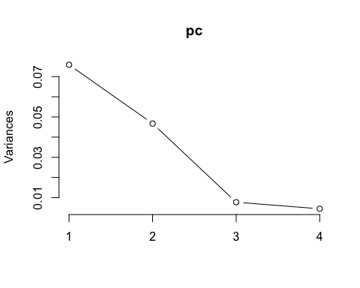

**summary**(pc)

## Importance of components:  
##                           PC1    PC2     PC3     PC4  
## Standard deviation     0.2754 0.2162 0.08792 0.06687  
## Proportion of Variance 0.5628 0.3467 0.05735 0.03317  
## Cumulative Proportion  0.5628 0.9095 0.96683 1.00000

pc.extracted <- **as.data.frame**(**predict**(pc, newdata=fruit.nat))  
fruit.nat**$**PC1.all <- pc.extracted**$**PC1   
*# annual fecundity*  
fit<-**lme**(**sqrt**(Total.SeedsPerPlant)**~**PC1.all**\***Morph, random=**~**1**|**Site, data=fruit.nat, method="ML", na.action=na.omit)    
**anova.lme**(fit)

##               numDF denDF   F-value p-value  
## (Intercept)       1    43 22.567977  <.0001  
## PC1.all           1    43  0.365077  0.5489  
## Morph             1    43  0.000722  0.9787  
## PC1.all:Morph     1    43  0.012103  0.9129

**ggplot**(fruit.nat, **aes**(x=Avg.CorollaFlare,y=No.SeedsPerFruit, color=Morph, shape=Treatment)) **+**  
 **scale_shape_manual**(values=**c**(16,17)) **+**  
 **geom_point**(size=4) **+**   
 **scale_y_sqrt**()**+**  
 **scale_colour_manual**(values=**c**("blue", "red")) **+**  
 **theme_bw**() **+**  
 **theme**(panel.grid.major = **element_blank**(), panel.grid.minor = **element_blank**(), text =**element_text**(size=20))

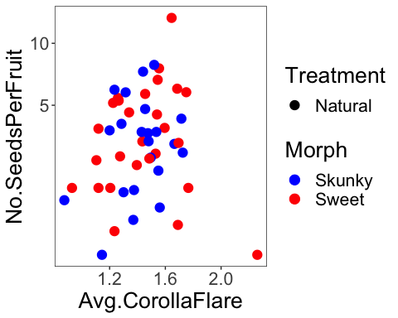

**All morphs: site, habitat and morph are random effects…**

**Seeds per fruit**

**qqnorm**(fruit.sm**$**No.SeedsPerFruit)  
**qqline**(fruit.sm**$**No.SeedsPerFruit)

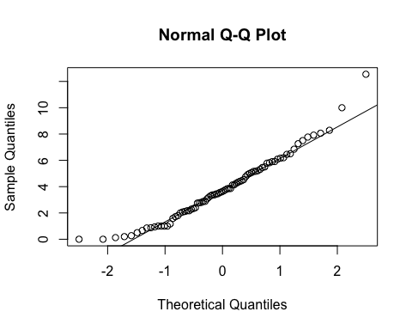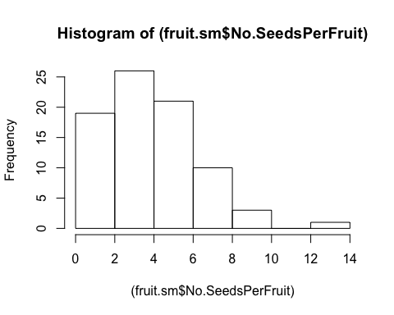

**hist**((fruit.sm**$**No.SeedsPerFruit))

**hist**(**sqrt**(fruit.sm**$**No.SeedsPerFruit))

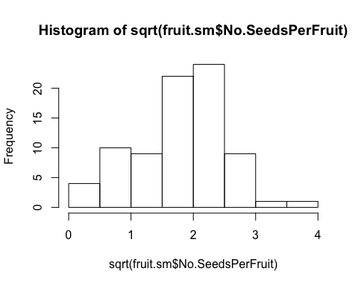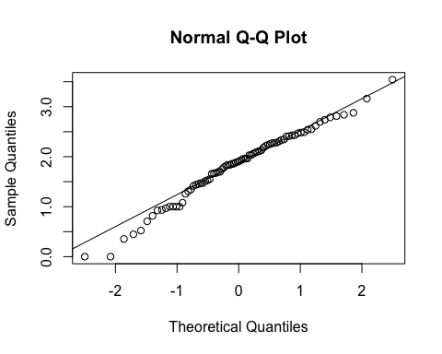

**qqnorm**(**sqrt**(fruit.sm**$**No.SeedsPerFruit))  
**qqline**(**sqrt**(fruit.sm**$**No.SeedsPerFruit))

fit<-**lme**(**sqrt**(No.SeedsPerFruit)**~**Treatment**\***Avg.CorollaFlare, random=**~**1**|**Site**/**Habitat**/**Morph, data=fruit.sm, method="ML", na.action=na.omit)    
**anova.lme**(fit)

##                            numDF denDF   F-value p-value  
## (Intercept)                    1    66 24.247198  <.0001  
## Treatment                      1    66  1.447231  0.2333  
## Avg.CorollaFlare               1    66  0.536050  0.4667  
## Treatment:Avg.CorollaFlare     1    66  4.220481  0.0439

**summary**(fit) *# sign. dif by treatment but difficult to interpret figures, if transformed looks like both go up with corolla flare and only intercept is different...*

## Linear mixed-effects model fit by maximum likelihood  
##  Data: fruit.sm   
##        AIC      BIC    logLik  
##   161.6144 180.6706 -72.80718  
##   
## Random effects:  
##  Formula: ~1 | Site  
##         (Intercept)  
## StdDev:   0.5302427  
##   
##  Formula: ~1 | Habitat %in% Site  
##         (Intercept)  
## StdDev: 0.001240764  
##   
##  Formula: ~1 | Morph %in% Habitat %in% Site  
##         (Intercept)  Residual  
## StdDev: 0.004869573 0.5681116  
##   
## Fixed effects: sqrt(No.SeedsPerFruit) ~ Treatment * Avg.CorollaFlare   
##                                                Value Std.Error DF  
## (Intercept)                                2.6012395 0.6482470 66  
## TreatmentSupplementation                  -1.7323075 0.9364563 66  
## Avg.CorollaFlare                          -0.7572772 0.3995328 66  
## TreatmentSupplementation:Avg.CorollaFlare  1.2729677 0.6196356 66  
##                                             t-value p-value  
## (Intercept)                                4.012729  0.0002  
## TreatmentSupplementation                  -1.849854  0.0688  
## Avg.CorollaFlare                          -1.895407  0.0624  
## TreatmentSupplementation:Avg.CorollaFlare  2.054381  0.0439  
##  Correlation:   
##                                           (Intr) TrtmnS Avg.CF  
## TreatmentSupplementation                  -0.563                
## Avg.CorollaFlare                          -0.864  0.646         
## TreatmentSupplementation:Avg.CorollaFlare  0.559 -0.988 -0.653  
##   
## Standardized Within-Group Residuals:  
##          Min           Q1          Med           Q3          Max   
## -2.510388786 -0.610062286  0.006335621  0.603225455  2.903829831   
##   
## Number of Observations: 80  
## Number of Groups:   
##                         Site            Habitat %in% Site   
##                            3                            6   
## Morph %in% Habitat %in% Site   
##                           11

fruit.nat <- **subset**(fruit.sm, Treatment**==**"Natural")  
fruit.sup <- **subset**(fruit.sm, Treatment**==**"Supplementation")  
  
fit<-**lme**(**sqrt**(No.SeedsPerFruit)**~**Avg.CorollaFlare, random=**~**1**|**Site**/**Habitat, data=fruit.nat, method="ML")  
**anova.lme**(fit)

##                  numDF denDF   F-value p-value  
## (Intercept)          1    42 21.937187  <.0001  
## Avg.CorollaFlare     1    42  3.502779  0.0682

fit<-**lme**(**sqrt**(No.SeedsPerFruit)**~**Avg.CorollaFlare, random=**~**1**|**Site**/**Habitat, data=fruit.sup, method="ML")  
**anova.lme**(fit)

##                  numDF denDF   F-value p-value  
## (Intercept)          1    26 122.89167  <.0001  
## Avg.CorollaFlare     1    26   1.47888  0.2349

fit<-**lme**(**sqrt**(No.SeedsPerFruit)**~**Treatment**\***Avg.TubeL, random=**~**1**|**Site**/**Habitat**/**Morph, data=fruit.sm, method="ML")    
**anova.lme**(fit)

##                     numDF denDF  F-value p-value  
## (Intercept)             1    66 38.93130  <.0001  
## Treatment               1    66  1.55398  0.2170  
## Avg.TubeL               1    66  0.49422  0.4845  
## Treatment:Avg.TubeL     1    66  0.00934  0.9233

**summary**(fit)

## Linear mixed-effects model fit by maximum likelihood  
##  Data: fruit.sm   
##        AIC      BIC    logLik  
##   165.6285 184.6848 -74.81427  
##   
## Random effects:  
##  Formula: ~1 | Site  
##         (Intercept)  
## StdDev:   0.4123721  
##   
##  Formula: ~1 | Habitat %in% Site  
##          (Intercept)  
## StdDev: 8.419897e-06  
##   
##  Formula: ~1 | Morph %in% Habitat %in% Site  
##          (Intercept)  Residual  
## StdDev: 2.002014e-05 0.5883774  
##   
## Fixed effects: sqrt(No.SeedsPerFruit) ~ Treatment * Avg.TubeL   
##                                         Value Std.Error DF    t-value  
## (Intercept)                         1.9402069 0.6864378 66  2.8264861  
## TreatmentSupplementation            0.0901505 1.0325704 66  0.0873069  
## Avg.TubeL                          -0.2344412 0.3834360 66 -0.6114220  
## TreatmentSupplementation:Avg.TubeL  0.0593126 0.6137781 66  0.0966352  
##                                    p-value  
## (Intercept)                         0.0062  
## TreatmentSupplementation            0.9307  
## Avg.TubeL                           0.5430  
## TreatmentSupplementation:Avg.TubeL  0.9233  
##  Correlation:   
##                                    (Intr) TrtmnS Avg.TL  
## TreatmentSupplementation           -0.565                
## Avg.TubeL                          -0.925  0.607         
## TreatmentSupplementation:Avg.TubeL  0.568 -0.990 -0.620  
##   
## Standardized Within-Group Residuals:  
##         Min          Q1         Med          Q3         Max   
## -3.38139377 -0.47368832 -0.01464879  0.64180310  2.62453143   
##   
## Number of Observations: 80  
## Number of Groups:   
##                         Site            Habitat %in% Site   
##                            3                            6   
## Morph %in% Habitat %in% Site   
##                           11

fit<-**lme**(**sqrt**(No.SeedsPerFruit)**~**Avg.LobeL, random=**~**1**|**Site**/**Habitat**/**Morph, data=fruit.nat, method="ML")    
**anova.lme**(fit)

##             numDF denDF   F-value p-value  
## (Intercept)     1    38 26.814395  <.0001  
## Avg.LobeL       1    38  1.957909  0.1698

**summary**(fit)

## Linear mixed-effects model fit by maximum likelihood  
##  Data: fruit.nat   
##        AIC      BIC    logLik  
##   113.4344 124.7854 -50.71722  
##   
## Random effects:  
##  Formula: ~1 | Site  
##         (Intercept)  
## StdDev:   0.4653158  
##   
##  Formula: ~1 | Habitat %in% Site  
##          (Intercept)  
## StdDev: 0.0001801231  
##   
##  Formula: ~1 | Morph %in% Habitat %in% Site  
##         (Intercept)  Residual  
## StdDev:   0.2036621 0.6169597  
##   
## Fixed effects: sqrt(No.SeedsPerFruit) ~ Avg.LobeL   
##                 Value Std.Error DF   t-value p-value  
## (Intercept)  2.427324  0.696835 38  3.483355  0.0013  
## Avg.LobeL   -1.271840  0.908942 38 -1.399253  0.1698  
##  Correlation:   
##           (Intr)  
## Avg.LobeL -0.904  
##   
## Standardized Within-Group Residuals:  
##         Min          Q1         Med          Q3         Max   
## -2.16376478 -0.56412866 -0.02738196  0.70387210  2.30765341   
##   
## Number of Observations: 49  
## Number of Groups:   
##                         Site            Habitat %in% Site   
##                            3                            6   
## Morph %in% Habitat %in% Site   
##                           10

**ggplot**(fruit.sm, **aes**(x=Avg.CorollaFlare,y=No.SeedsPerFruit, color=Treatment, shape=Treatment)) **+**  
 **geom_point**(size=4) **+**   
 **scale_colour_manual**(values=**c**("blue", "red")) **+**  
 **xlim**(0.8,2.4) **+**  
 **ylim**(0,15) **+**  
 **geom_smooth**(method='lm', **aes**(linetype=Treatment), fill=NA) **+**  
 **ylab**("Number of seeds per fruit") **+**  
 **xlab**("Corolla Flare (cm)") **+**  
 **geom_hline**(yintercept=0, linetype="dashed") **+**  
 **theme_bw**() **+**  
 **theme**(panel.grid.major = **element_blank**(), panel.grid.minor = **element_blank**(), text =**element_text**(size=20))

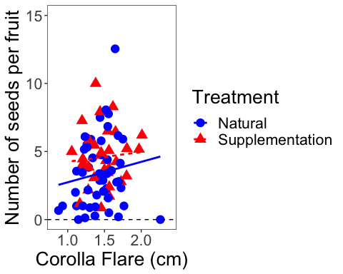

**ggplot**(fruit.sm, **aes**(x=Avg.CorollaFlare,y=No.SeedsPerFruit, color=Treatment, shape=Treatment)) **+**  
 **geom_point**(size=4) **+**   
 **scale_y_continuous**(limits=**c**(0,15), trans="sqrt") **+**  
 **xlim**(0.8,2.4) **+**  
 **scale_colour_manual**(values=**c**("blue", "red")) **+**  
 **geom_smooth**(method='lm', **aes**(linetype=Treatment), fill=NA) **+**  
 **ylab**("Number of seeds per fruit") **+**  
 **xlab**("Corolla Flare (cm)") **+**  
 **geom_hline**(yintercept=0, linetype="dashed") **+**  
 **theme_bw**() **+**  
 **theme**(panel.grid.major = **element_blank**(), panel.grid.minor = **element_blank**(), text =**element_text**(size=20))

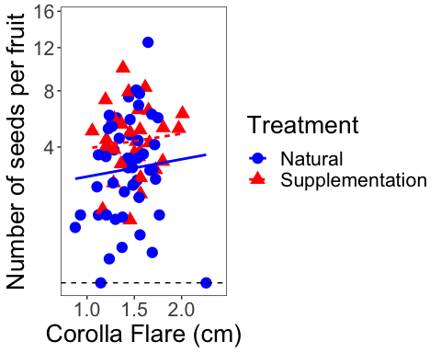

**ggplot**(fruit.sm, **aes**(x=Avg.TubeL,y=No.SeedsPerFruit, color=Treatment, shape=Treatment)) **+**  
 **geom_point**(size=4) **+**   
 **scale_y_continuous**(limits=**c**(0,15), trans="sqrt") **+**  
 **scale_colour_manual**(values=**c**("blue", "red")) **+**  
 **ylab**("Number of seeds per fruit") **+**  
 **xlab**("Tube Length (cm)") **+**  **geom_hline**(yintercept=0, linetype="dashed") **+**  
 **theme_bw**() **+**  
 **theme**(panel.grid.major = **element_blank**(), panel.grid.minor = **element_blank**(), text =**element_text**(size=20))

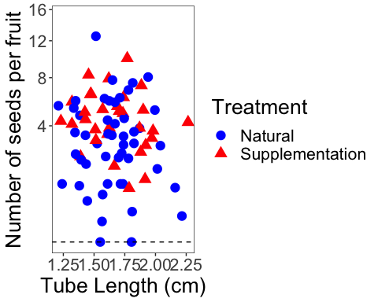

**ggplot**(fruit.sm, **aes**(x=Avg.LobeL,y=No.SeedsPerFruit, color=Treatment, shape=Treatment)) **+**  
 **geom_point**(size=4) **+**   
 **scale_y_sqrt**()**+**  
 **scale_colour_manual**(values=**c**("blue", "red")) **+**  
 **geom_smooth**(method='lm', fill=NA) **+**  
 **theme_bw**() **+**  
 **theme**(panel.grid.major = **element_blank**(), panel.grid.minor = **element_blank**(), text =**element_text**(size=20))

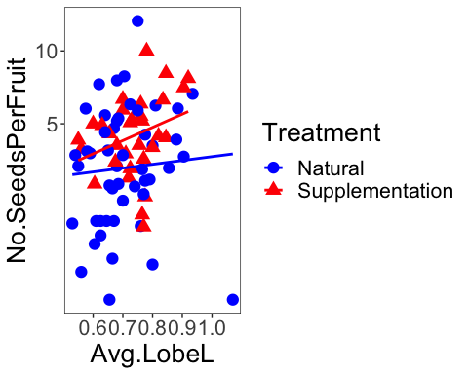

**Add tube length and lobe length to get corolla length**

fruit.sm**$**CorollaL <- fruit.sm**$**Avg.TubeL **+** fruit.sm**$**Avg.TubeL  
fit<-**lme**(**sqrt**(No.SeedsPerFruit)**~**Treatment**\***CorollaL, random=**~**1**|**Site**/**Habitat**/**Morph, data=fruit.sm, method="ML")    
**anova.lme**(fit)

##                    numDF denDF  F-value p-value  
## (Intercept)            1    66 38.93130  <.0001  
## Treatment              1    66  1.55398  0.2170  
## CorollaL               1    66  0.49422  0.4845  
## Treatment:CorollaL     1    66  0.00934  0.9233

**summary**(fit)

## Linear mixed-effects model fit by maximum likelihood  
##  Data: fruit.sm   
##        AIC      BIC    logLik  
##   165.6285 184.6848 -74.81427  
##   
## Random effects:  
##  Formula: ~1 | Site  
##         (Intercept)  
## StdDev:   0.4123721  
##   
##  Formula: ~1 | Habitat %in% Site  
##          (Intercept)  
## StdDev: 8.419897e-06  
##   
##  Formula: ~1 | Morph %in% Habitat %in% Site  
##          (Intercept)  Residual  
## StdDev: 2.002014e-05 0.5883774  
##   
## Fixed effects: sqrt(No.SeedsPerFruit) ~ Treatment * CorollaL   
##                                        Value Std.Error DF    t-value  
## (Intercept)                        1.9402069 0.6864378 66  2.8264861  
## TreatmentSupplementation           0.0901505 1.0325704 66  0.0873069  
## CorollaL                          -0.1172206 0.1917180 66 -0.6114220  
## TreatmentSupplementation:CorollaL  0.0296563 0.3068890 66  0.0966352  
##                                   p-value  
## (Intercept)                        0.0062  
## TreatmentSupplementation           0.9307  
## CorollaL                           0.5430  
## TreatmentSupplementation:CorollaL  0.9233  
##  Correlation:   
##                                   (Intr) TrtmnS CorllL  
## TreatmentSupplementation          -0.565                
## CorollaL                          -0.925  0.607         
## TreatmentSupplementation:CorollaL  0.568 -0.990 -0.620  
##   
## Standardized Within-Group Residuals:  
##         Min          Q1         Med          Q3         Max   
## -3.38139377 -0.47368832 -0.01464879  0.64180310  2.62453143   
##   
## Number of Observations: 80  
## Number of Groups:   
##                         Site            Habitat %in% Site   
##                            3                            6   
## Morph %in% Habitat %in% Site   
##                           11

**Seeds per plant**

**qqnorm**(fruit.sm**$**Total.SeedsPerPlant)  
**qqline**(fruit.sm**$**Total.SeedsPerPlant)

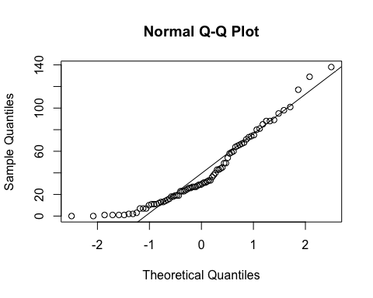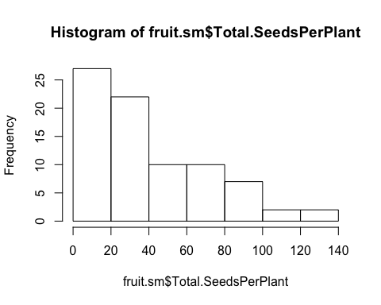

**hist**(fruit.sm**$**Total.SeedsPerPlant)

**qqnorm**(**sqrt**(fruit.sm**$**Total.SeedsPerPlant))  
**qqline**(**sqrt**(fruit.sm**$**Total.SeedsPerPlant))

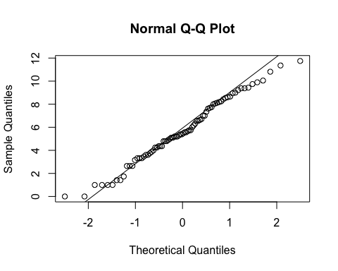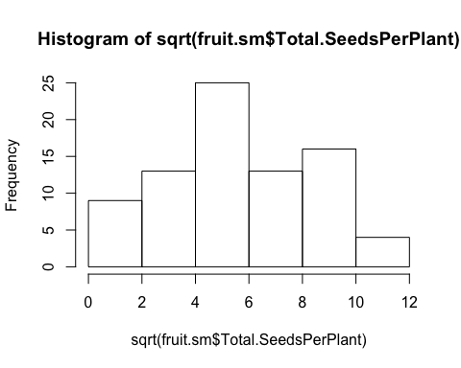

**hist**(**sqrt**(fruit.sm**$**Total.SeedsPerPlant))

fit<-**lme**(**sqrt**(Total.SeedsPerPlant)**~**Treatment**\***Avg.CorollaFlare, random=**~**1**|**Site**/**Habitat**/**Morph, data=fruit.sm, method="ML", na.action=na.omit)    
**anova.lme**(fit)

##                            numDF denDF   F-value p-value  
## (Intercept)                    1    66 21.843563  <.0001  
## Treatment                      1    66  0.029820  0.8634  
## Avg.CorollaFlare               1    66  0.489327  0.4867  
## Treatment:Avg.CorollaFlare     1    66  0.735103  0.3943

**summary**(fit)

## Linear mixed-effects model fit by maximum likelihood  
##  Data: fruit.sm   
##        AIC      BIC    logLik  
##   392.8875 411.9438 -188.4438  
##   
## Random effects:  
##  Formula: ~1 | Site  
##         (Intercept)  
## StdDev:    1.697221  
##   
##  Formula: ~1 | Habitat %in% Site  
##          (Intercept)  
## StdDev: 0.0002953548  
##   
##  Formula: ~1 | Morph %in% Habitat %in% Site  
##          (Intercept) Residual  
## StdDev: 4.397094e-05  2.43556  
##   
## Fixed effects: sqrt(Total.SeedsPerPlant) ~ Treatment * Avg.CorollaFlare   
##                                               Value Std.Error DF  
## (Intercept)                                7.503954  2.612035 66  
## TreatmentSupplementation                  -3.280218  3.992730 66  
## Avg.CorollaFlare                          -1.846873  1.696240 66  
## TreatmentSupplementation:Avg.CorollaFlare  2.267445  2.644616 66  
##                                              t-value p-value  
## (Intercept)                                2.8728387  0.0055  
## TreatmentSupplementation                  -0.8215478  0.4143  
## Avg.CorollaFlare                          -1.0888038  0.2802  
## TreatmentSupplementation:Avg.CorollaFlare  0.8573818  0.3943  
##  Correlation:   
##                                           (Intr) TrtmnS Avg.CF  
## TreatmentSupplementation                  -0.591                
## Avg.CorollaFlare                          -0.912  0.642         
## TreatmentSupplementation:Avg.CorollaFlare  0.587 -0.988 -0.650  
##   
## Standardized Within-Group Residuals:  
##        Min         Q1        Med         Q3        Max   
## -2.0573303 -0.7762172 -0.1154295  0.7955889  2.2995789   
##   
## Number of Observations: 80  
## Number of Groups:   
##                         Site            Habitat %in% Site   
##                            3                            6   
## Morph %in% Habitat %in% Site   
##                           11

fit<-**lme**(**sqrt**(Total.SeedsPerPlant)**~**Treatment**\***Avg.TubeL, random=**~**1**|**Site**/**Habitat**/**Morph, data=fruit.sm, method="ML", na.action=na.omit)    
**anova.lme**(fit)

##                     numDF denDF   F-value p-value  
## (Intercept)             1    66 30.454222  <.0001  
## Treatment               1    66  0.056695  0.8125  
## Avg.TubeL               1    66  0.005612  0.9405  
## Treatment:Avg.TubeL     1    66  0.258884  0.6126

**summary**(fit)

## Linear mixed-effects model fit by maximum likelihood  
##  Data: fruit.sm   
##        AIC      BIC    logLik  
##   393.7481 412.8044 -188.8741  
##   
## Random effects:  
##  Formula: ~1 | Site  
##         (Intercept)  
## StdDev:    1.416269  
##   
##  Formula: ~1 | Habitat %in% Site  
##          (Intercept)  
## StdDev: 0.0001006108  
##   
##  Formula: ~1 | Morph %in% Habitat %in% Site  
##          (Intercept) Residual  
## StdDev: 6.521535e-05 2.464404  
##   
## Fixed effects: sqrt(Total.SeedsPerPlant) ~ Treatment * Avg.TubeL   
##                                        Value Std.Error DF    t-value  
## (Intercept)                         4.260554  2.814298 66  1.5138961  
## TreatmentSupplementation            2.324798  4.321108 66  0.5380097  
## Avg.TubeL                           0.412854  1.605893 66  0.2570865  
## TreatmentSupplementation:Avg.TubeL -1.306949  2.568658 66 -0.5088062  
##                                    p-value  
## (Intercept)                         0.1348  
## TreatmentSupplementation            0.5924  
## Avg.TubeL                           0.7979  
## TreatmentSupplementation:Avg.TubeL  0.6126  
##  Correlation:   
##                                    (Intr) TrtmnS Avg.TL  
## TreatmentSupplementation           -0.578                
## Avg.TubeL                          -0.945  0.608         
## TreatmentSupplementation:Avg.TubeL  0.581 -0.990 -0.621  
##   
## Standardized Within-Group Residuals:  
##         Min          Q1         Med          Q3         Max   
## -2.55440949 -0.73454626 -0.06808465  0.77048855  2.21826177   
##   
## Number of Observations: 80  
## Number of Groups:   
##                         Site            Habitat %in% Site   
##                            3                            6   
## Morph %in% Habitat %in% Site   
##                           11

**FLOWER SIZE by habitat and morph**

**Notes from Niki’s last analysis:**

*no difference in flower size by scent morph or habitat => sweet and skunky have the same size flowers*

flowers are cumberland pass are smaller than niwot ridge & penn mountain.

*This parallels differences in seed set, but when we test for a direct relationship via regression (see below), there is no difference*

*Perhaps it has more to do with a weather effect, since selection doesn’t vary among sites??? [stilll need to verify this last statement]*

**qqnorm**(flwr.nat**$**Avg.CorollaFlare)  
**qqline**(flwr.nat**$**Avg.CorollaFlare)

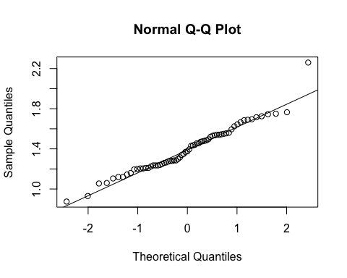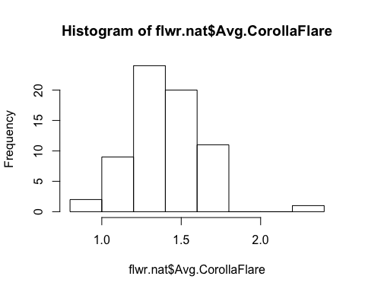

**hist**(flwr.nat**$**Avg.CorollaFlare)

fit<-**lm**(Avg.CorollaFlare**~**Site, data=flwr.nat, na.action=na.omit)    
**anova**(fit)

## Analysis of Variance Table  
##   
## Response: Avg.CorollaFlare  
##           Df  Sum Sq Mean Sq F value    Pr(>F)      
## Site       2 0.88461  0.4423  10.286 0.0001339 ***  
## Residuals 64 2.75216  0.0430                        
## ---  
## Signif. codes:  0 '***' 0.001 '**' 0.01 '*' 0.05 '.' 0.1 ' ' 1

**TukeyHSD**(**aov**(Avg.CorollaFlare**~**Site, data=flwr.nat, na.action=na.omit))

##   Tukey multiple comparisons of means  
##     95% family-wise confidence level  
##   
## Fit: aov(formula = Avg.CorollaFlare ~ Site, data = flwr.nat, na.action = na.omit)  
##   
## $Site  
##                                     diff         lwr       upr     p adj  
## Niwot Ridge-Cumberland Pass   0.22016082  0.05650121 0.3838204 0.0055154  
## Penn Mountain-Cumberland Pass 0.26943860  0.12355236 0.4153248 0.0001098  
## Penn Mountain-Niwot Ridge     0.04927778 -0.09906877 0.1976243 0.7061896

**ggplot**(flwr.nat, **aes**(x=Site,y=Avg.CorollaFlare)) **+**  
 **geom_boxplot**() **+**   
 **theme_bw**() **+**  
 **theme**(panel.grid.major = **element_blank**(), panel.grid.minor = **element_blank**(), text =**element_text**(size=20))

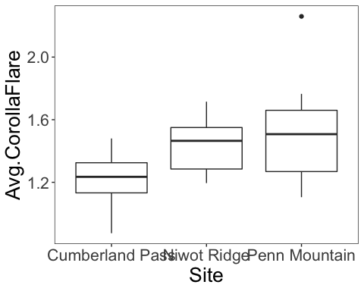

fit<-**lme**(Avg.CorollaFlare**~**Site, random=**~**1**|**Morph, data=flwr.nat, method="ML", na.action=na.omit)    
**anova.lme**(fit)

##             numDF denDF   F-value p-value  
## (Intercept)     1    63 3043.6925  <.0001  
## Site            2    63   10.2855   1e-04

fit<-**lme**(Avg.CorollaFlare**~**Habitat**\***Morph, random=**~**1**|**Site, data=flwr.nat, method="ML", na.action=na.omit)    
**anova.lme**(fit)

##               numDF denDF  F-value p-value  
## (Intercept)       1    61 326.7009  <.0001  
## Habitat           1    61   1.7298  0.1934  
## Morph             1    61   0.4290  0.5150  
## Habitat:Morph     1    61   0.1262  0.7237

fit<-**lm**(Avg.CorollaFlare**~**Site**\***Morph, data=flwr.nat, na.action=na.omit)    
**Anova**(fit,type="III")

## Anova Table (Type III tests)  
##   
## Response: Avg.CorollaFlare  
##              Sum Sq Df  F value Pr(>F)      
## (Intercept) 16.3840  1 380.9275 <2e-16 ***  
## Site         0.1612  2   1.8736 0.1623      
## Morph        0.0814  1   1.8932 0.1739      
## Site:Morph   0.1279  2   1.4865 0.2342      
## Residuals    2.6237 61                      
## ---  
## Signif. codes:  0 '***' 0.001 '**' 0.01 '*' 0.05 '.' 0.1 ' ' 1

fit<-**lm**(Avg.CorollaFlare**~**Site**\***Morph**\***Habitat, data=flwr.nat, na.action=na.omit)    
**anova**(fit) *# unbalanced, so cannot run type 3.*

## Analysis of Variance Table  
##   
## Response: Avg.CorollaFlare  
##               Df  Sum Sq Mean Sq F value    Pr(>F)      
## Site           2 0.88461 0.44230 10.1313 0.0001719 ***  
## Morph          1 0.00063 0.00063  0.0145 0.9046879      
## Habitat        1 0.10749 0.10749  2.4623 0.1221465      
## Site:Morph     2 0.08515 0.04258  0.9752 0.3833099      
## Site:Habitat   2 0.06354 0.03177  0.7277 0.4874450      
## Morph:Habitat  1 0.00688 0.00688  0.1577 0.6927604      
## Residuals     57 2.48846 0.04366                        
## ---  
## Signif. codes:  0 '***' 0.001 '**' 0.01 '*' 0.05 '.' 0.1 ' ' 1

**qqnorm**(flwr.nat**$**Avg.TubeL)  
**qqline**(flwr.nat**$**Avg.TubeL)

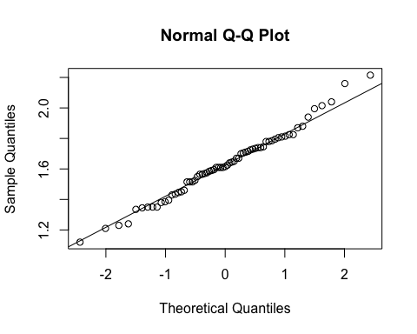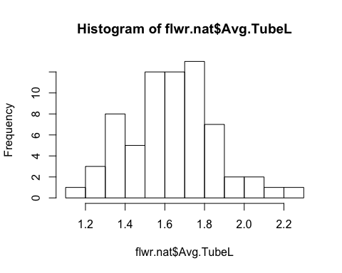

**hist**(flwr.nat**$**Avg.TubeL)

fit<-**lm**(Avg.TubeL**~**Site, data=flwr.nat, na.action=na.omit)    
**anova**(fit)

## Analysis of Variance Table  
##   
## Response: Avg.TubeL  
##           Df Sum Sq  Mean Sq F value Pr(>F)  
## Site       2 0.0433 0.021657  0.4341 0.6497  
## Residuals 64 3.1927 0.049887

fit<-**lme**(Avg.TubeL**~**Habitat**\***Morph, random=**~**1**|**Site, data=flwr.nat, method="ML", na.action=na.omit)    
**anova.lme**(fit)

##               numDF denDF  F-value p-value  
## (Intercept)       1    61 3620.624  <.0001  
## Habitat           1    61    1.668  0.2014  
## Morph             1    61    0.663  0.4186  
## Habitat:Morph     1    61    0.608  0.4384

fit<-**lm**(Avg.TubeL**~**Site**\***Morph, data=flwr.nat, na.action=na.omit)    
**Anova**(fit,type="III")

## Anova Table (Type III tests)  
##   
## Response: Avg.TubeL  
##              Sum Sq Df  F value  Pr(>F)      
## (Intercept) 28.8830  1 609.4369 < 2e-16 ***  
## Site         0.1386  2   1.4621 0.23977      
## Morph        0.0222  1   0.4675 0.49675      
## Site:Morph   0.2398  2   2.5294 0.08804 .    
## Residuals    2.8910 61                       
## ---  
## Signif. codes:  0 '***' 0.001 '**' 0.01 '*' 0.05 '.' 0.1 ' ' 1

fit<-**lm**(Avg.TubeL**~**Site**\***Morph**\***Habitat, data=flwr.nat, na.action=na.omit)    
**anova**(fit) *# unbalanced, so cannot run type 3.*

## Analysis of Variance Table  
##   
## Response: Avg.TubeL  
##               Df  Sum Sq  Mean Sq F value  Pr(>F)    
## Site           2 0.04331 0.021657  0.4992 0.60967    
## Morph          1 0.06202 0.062016  1.4294 0.23682    
## Habitat        1 0.05313 0.053134  1.2246 0.27310    
## Site:Morph     2 0.28845 0.144226  3.3241 0.04310 *  
## Site:Habitat   2 0.24178 0.120890  2.7863 0.07006 .  
## Morph:Habitat  1 0.07427 0.074267  1.7117 0.19602    
## Residuals     57 2.47309 0.043387                    
## ---  
## Signif. codes:  0 '***' 0.001 '**' 0.01 '*' 0.05 '.' 0.1 ' ' 1

measures <- **c**("Avg.CorollaFlare", "Avg.TubeL", "Avg.LobeL", "Avg.LobW")  
flwr.size<-**as.matrix**(**subset**(flwr.nat, select=measures))  
pc<-**prcomp**(flwr.size,center=TRUE)  
**print**(pc)

## Standard deviations (1, .., p=4):  
## [1] 0.26375496 0.20976301 0.08825506 0.06486573  
##   
## Rotation (n x k) = (4 x 4):  
##                        PC1         PC2         PC3         PC4  
## Avg.CorollaFlare 0.8192268 -0.40655518 -0.35567419 -0.19255163  
## Avg.TubeL        0.4468626  0.89354307 -0.01435364  0.04109264  
## Avg.LobeL        0.2435860 -0.08932854  0.87933763 -0.39931394  
## Avg.LobW         0.2642860 -0.16826787  0.31631500  0.89542372

**plot**(pc, type="l")

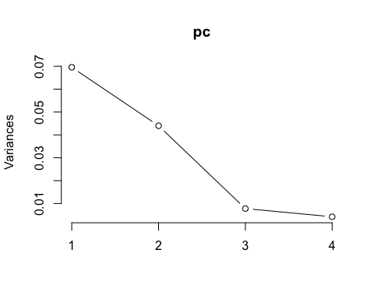

**summary**(pc)

## Importance of components:  
##                           PC1    PC2     PC3     PC4  
## Standard deviation     0.2638 0.2098 0.08826 0.06487  
## Proportion of Variance 0.5540 0.3504 0.06203 0.03351  
## Cumulative Proportion  0.5540 0.9045 0.96649 1.00000

pc.extracted <- **as.data.frame**(**predict**(pc, newdata=flwr.nat))  
flwr.nat**$**PC1.all <- pc.extracted**$**PC1   
**qqnorm**(flwr.nat**$**PC1.all)  
**qqline**(flwr.nat**$**PC1.all)

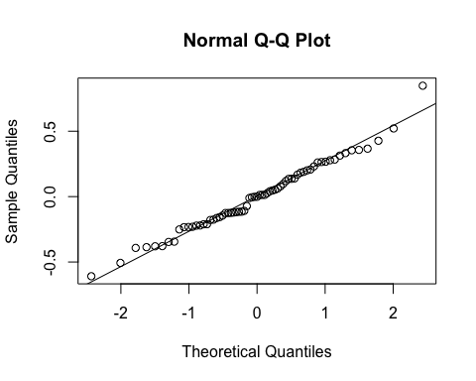

fit<-**lm**(PC1.all**~**Site, data=flwr.nat, na.action=na.omit)    
**anova**(fit)

## Analysis of Variance Table  
##   
## Response: PC1.all  
##           Df Sum Sq Mean Sq F value   Pr(>F)     
## Site       2 0.6925 0.34625  5.6837 0.005344 **  
## Residuals 64 3.8989 0.06092                      
## ---  
## Signif. codes:  0 '***' 0.001 '**' 0.01 '*' 0.05 '.' 0.1 ' ' 1

**ggplot**(flwr.nat, **aes**(x=Site,y=PC1.all)) **+**  
 **geom_boxplot**() **+**   
 **theme_bw**() **+**  
 **theme**(panel.grid.major = **element_blank**(), panel.grid.minor = **element_blank**(), text =**element_text**(size=20))

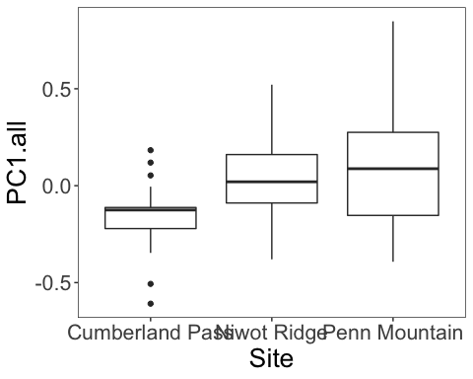

fit<-**lme**(PC1.all**~**Habitat**\***Morph, random=**~**1**|**Site, data=flwr.nat, method="ML", na.action=na.omit)    
**anova.lme**(fit)

##               numDF denDF   F-value p-value  
## (Intercept)       1    61 0.0324805  0.8576  
## Habitat           1    61 0.1139159  0.7369  
## Morph             1    61 0.2167850  0.6432  
## Habitat:Morph     1    61 0.4024498  0.5282

fit<-**lm**(PC1.all**~**Site**\***Morph, data=flwr.nat, na.action=na.omit)    
**Anova**(fit,type="III")

## Anova Table (Type III tests)  
##   
## Response: PC1.all  
##             Sum Sq Df F value Pr(>F)  
## (Intercept) 0.0884  1  1.4188 0.2382  
## Site        0.1338  2  1.0734 0.3482  
## Morph       0.0915  1  1.4683 0.2303  
## Site:Morph  0.0863  2  0.6924 0.5043  
## Residuals   3.8019 61